ME 231 Fluid Mechanics · Test #2 (Mon 11/9)
Textbook Practice Set
White & Xue, Fluid Mechanics 9th ed. · Ch 3 (Bernoulli), 4, 5, 6
These problems are not your assigned homework. They sit next to your HW problems in the book and test the same skills. Work each one on its engineering-paper page using Given / Find / Solution, then check the step-by-step solutions at the back.
# | Problem | Topic | Answer (self-check)
1 | P3.117 | Ch 3 · Bernoulli | H ≈ 8.5 m
2 | P3.121 | Ch 3 · Bernoulli + continuity | p₂ ≈ 169.4 kPa; Q ≈ 224 m³/h
3 | P3.126 | Ch 3 · Bernoulli / energy eq. | (a) 0.197 ft³/s (b) 0.084 ft³/s
4 | P4.3 | Ch 4 · Kinematics | a = 18i + 26j; V₄₀ = −5.39
5 | P4.17 | Ch 4 · Continuity | v_max ≈ 0.005 m/s
6 | P4.57 | Ch 4 · ψ and φ | ψ = (V/L)(2xy − y²); no φ
7 | P4.80 | Ch 4 · Exact Navier–Stokes | w = −(ρg/2μ)x(2δ − x)
8 | P5.25 | Ch 5 · Pi theorem | F/(ρV²D²) = f(ΩD/V, ρVD/μ)
9 | P5.31 | Ch 5 · Pi theorem | (Δp/L)D⁵/(ρQ²) = f(μD/(ρQ))
10 | P5.66 | Ch 5 · Similarity (cavitation no.) | 27 m/s; ≈ 26.5 m
11 | P5.71 | Ch 5 · Model scaling | D ≈ 15 cm
12 | P6.11 | Ch 6 · Energy eq. + manometer | Δp ≈ 46 kPa; h_f ≈ 1.70 m; f ≈ 0.025
13 | P6.14 | Ch 6 · Laminar flow | H ≳ 1.0 m turbulent; Q ≈ 1.85×10⁻⁶ m³/s
14 | P6.41 | Ch 6 · Turbulent, Type 2 | galvanized & steel OK; cast iron no
15 | P6.44 | Ch 6 · Turbulent, Type 1 | h_f ≈ 10.5 m; Δp ≈ 1.4 MPa
16 | P6.62 | Ch 6 · Pump + pipe system | ≈ 204 hp

Properties are from White Table A.3 at 20 °C (water ρ = 998 kg/m³, μ = 1.00×10⁻³ kg/(m·s)). All answers were checked numerically (solve2.py).

P3.117 · Ch 3 · Bernoulli · Test #2 practice
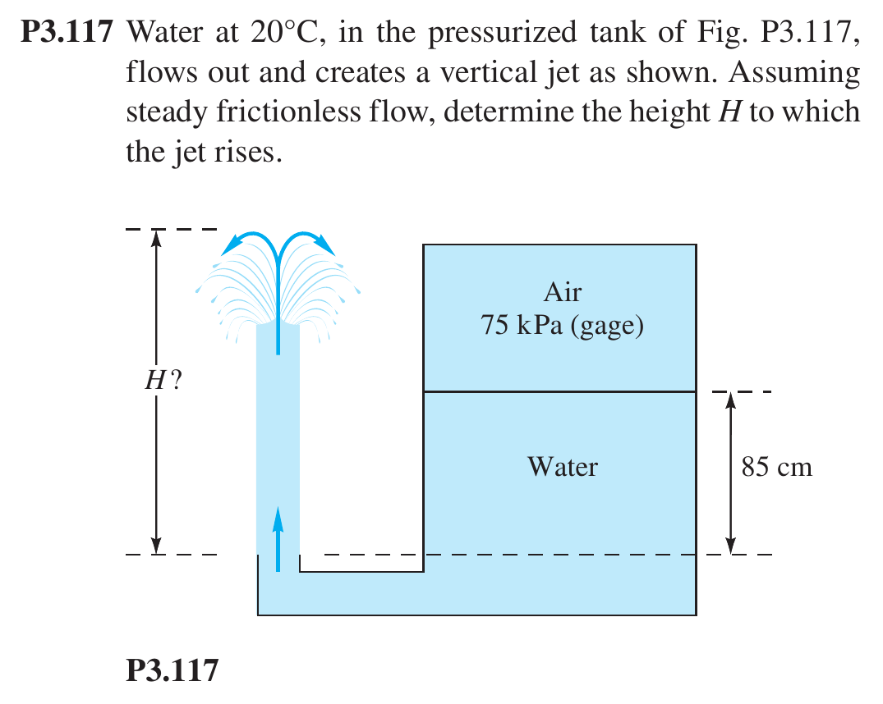

P3.121 · Ch 3 · Bernoulli + continuity · Test #2 practice
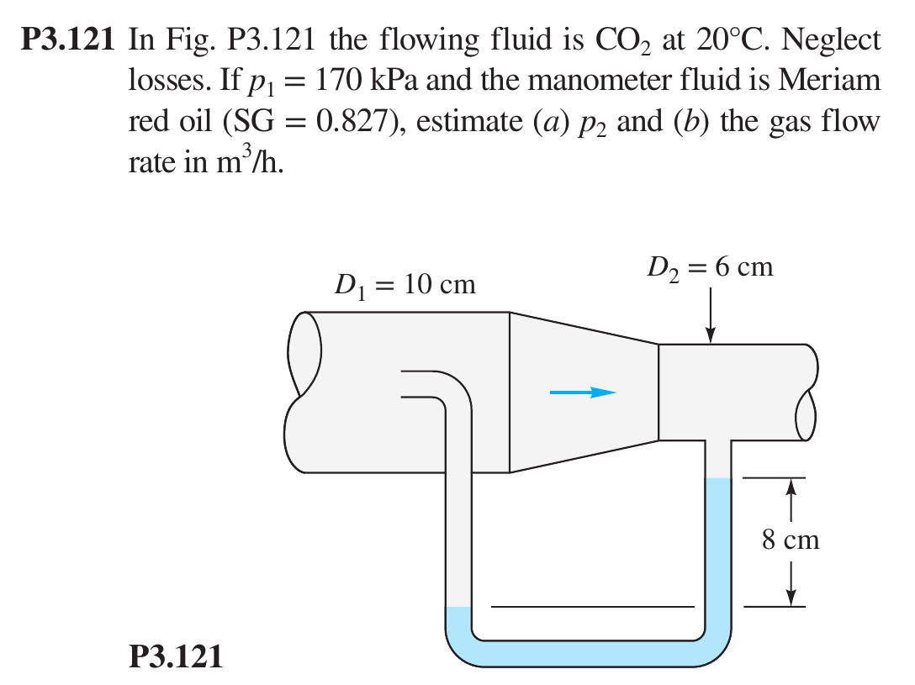

P3.126 · Ch 3 · Bernoulli / energy eq. · Test #2 practice
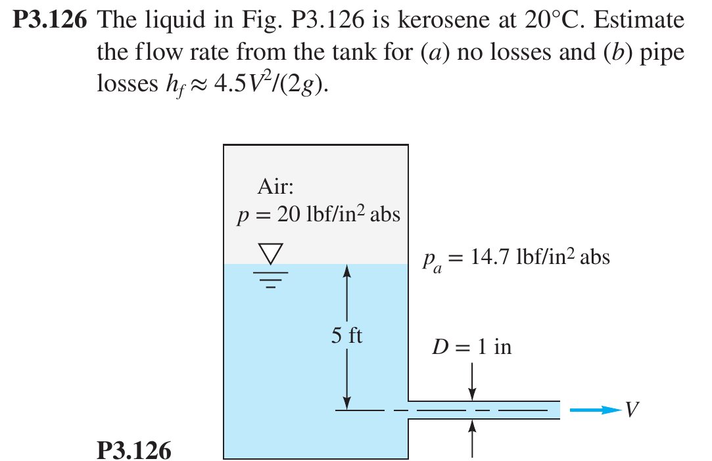

P4.3 · Ch 4 · Kinematics · Test #2 practice
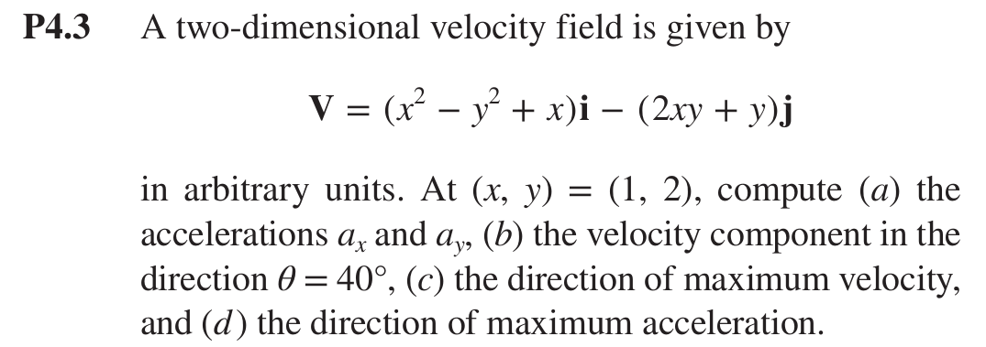

P4.17 · Ch 4 · Continuity · Test #2 practice
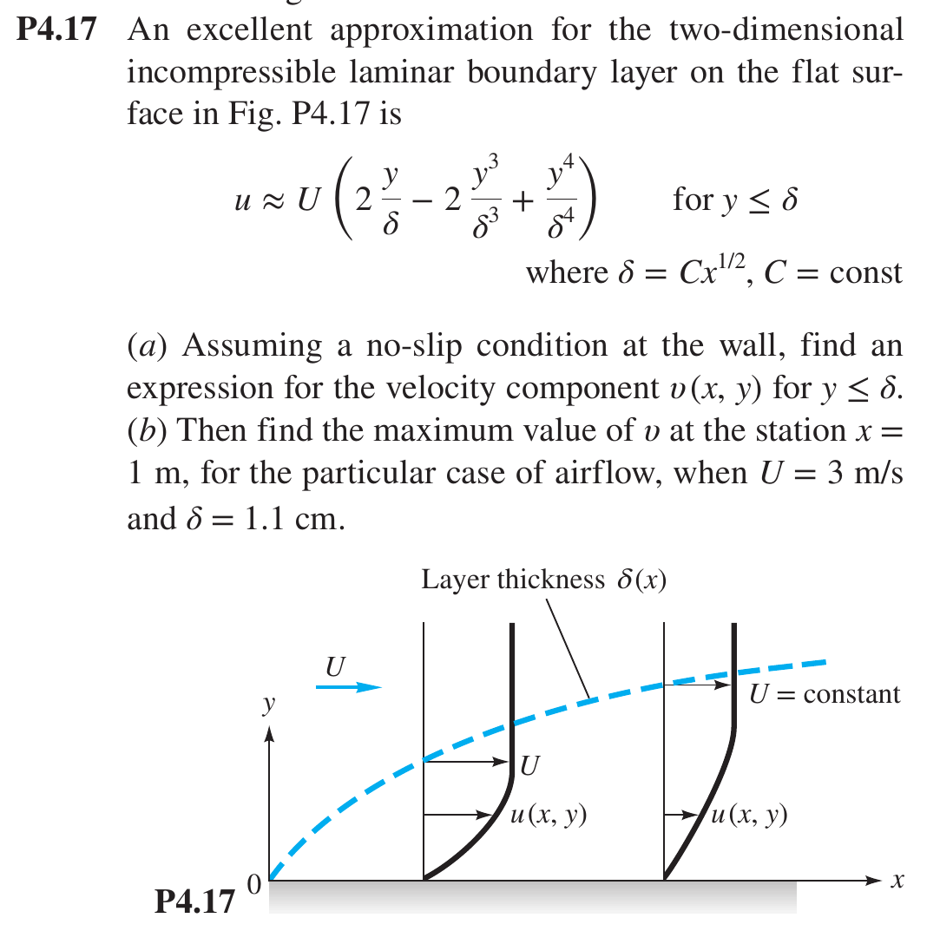

P4.57 · Ch 4 · ψ and φ · Test #2 practice
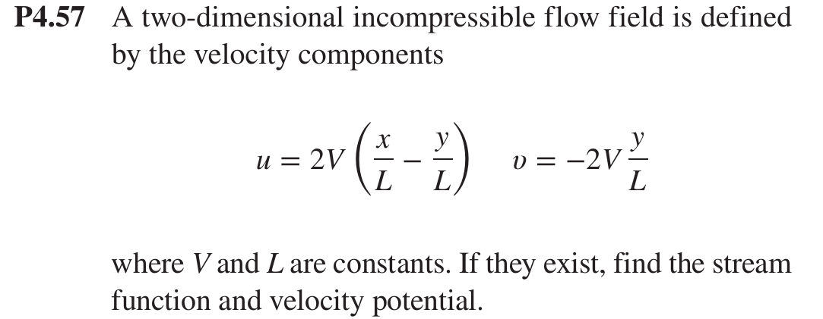

P4.80 · Ch 4 · Exact Navier–Stokes · Test #2 practice
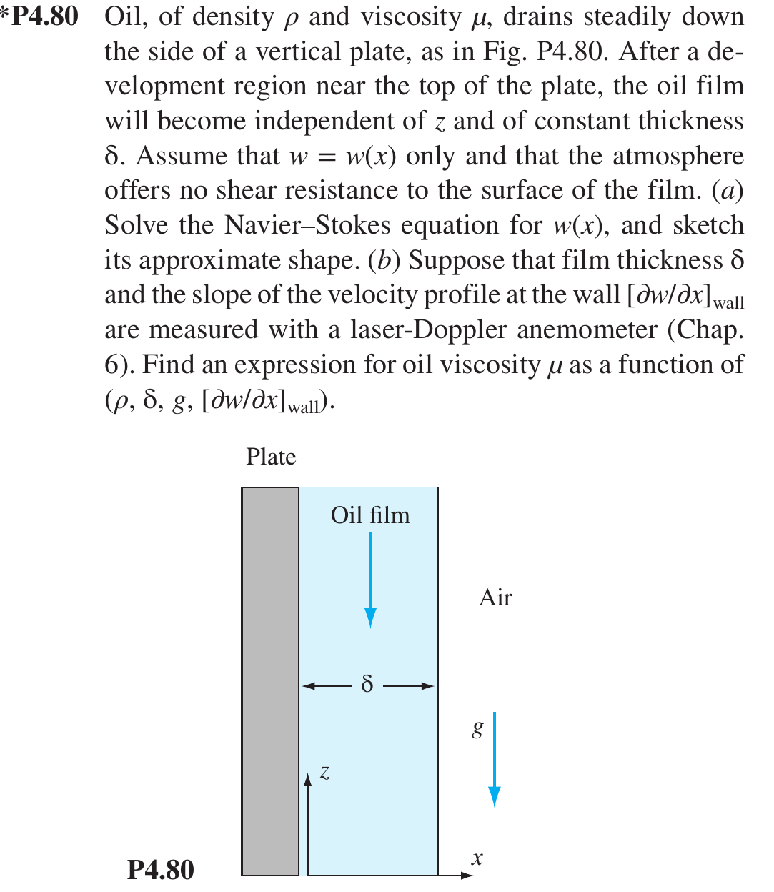

P5.25 · Ch 5 · Pi theorem · Test #2 practice
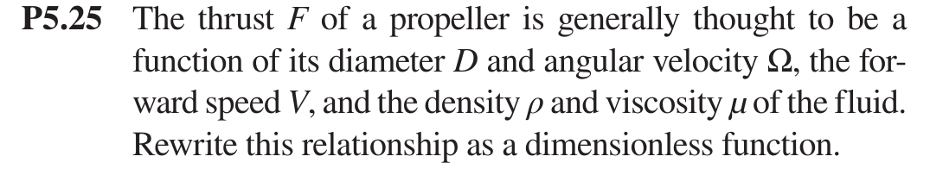

P5.31 · Ch 5 · Pi theorem · Test #2 practice
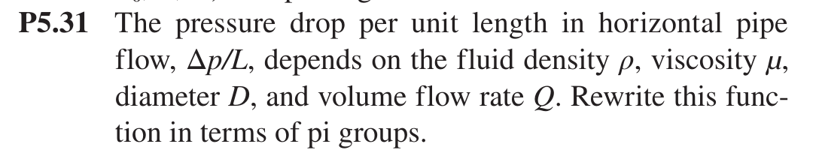

P5.66 · Ch 5 · Similarity (cavitation no.) · Test #2 practice
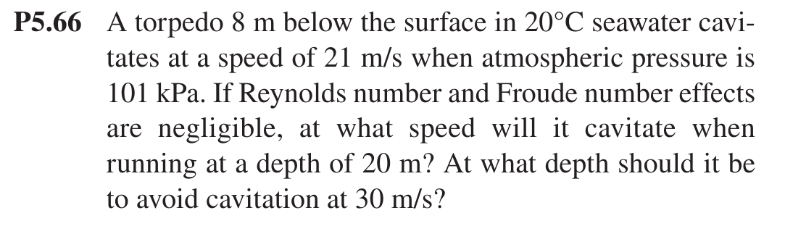

P5.71 · Ch 5 · Model scaling · Test #2 practice
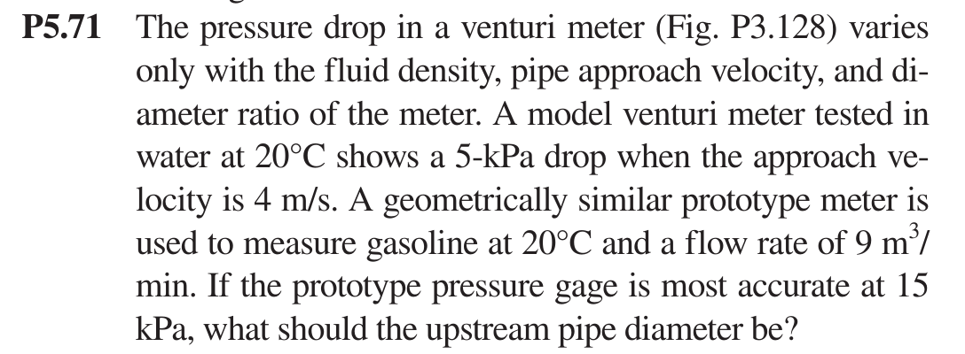

P6.11 · Ch 6 · Energy eq. + manometer · Test #2 practice
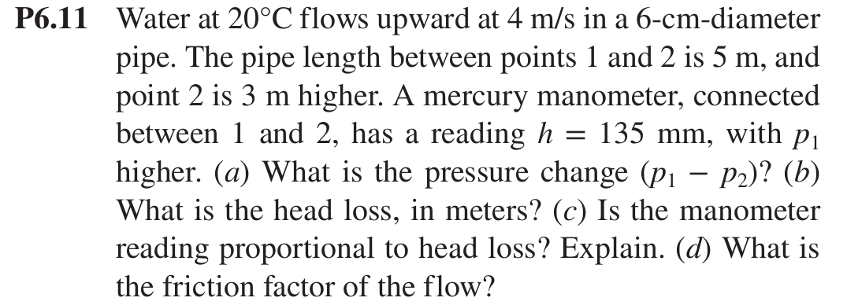

P6.14 · Ch 6 · Laminar flow · Test #2 practice
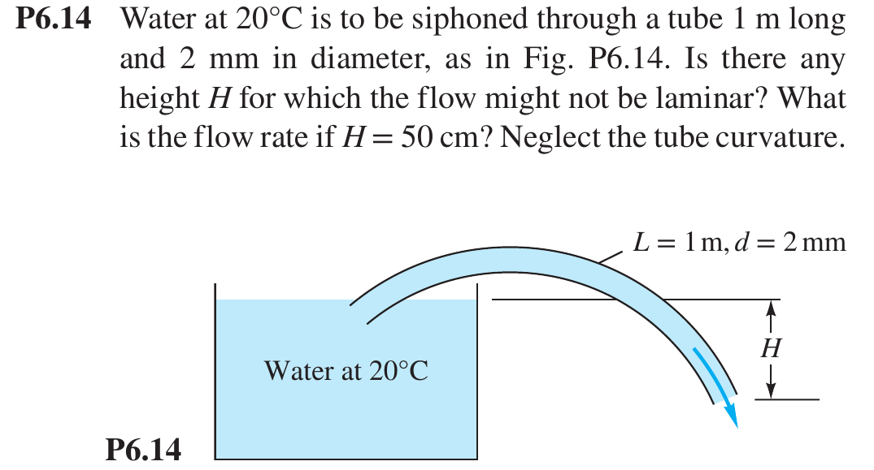

P6.41 · Ch 6 · Turbulent, Type 2 · Test #2 practice
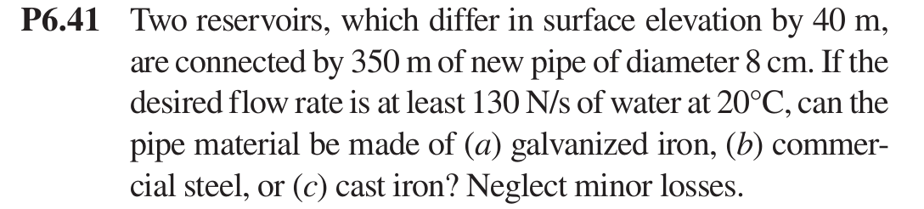

P6.44 · Ch 6 · Turbulent, Type 1 · Test #2 practice
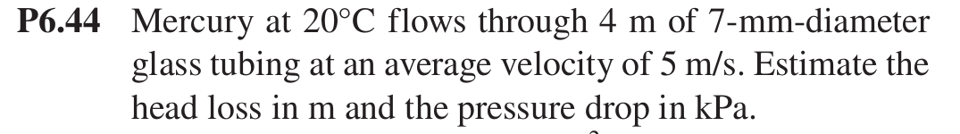

P6.62 · Ch 6 · Pump + pipe system · Test #2 practice
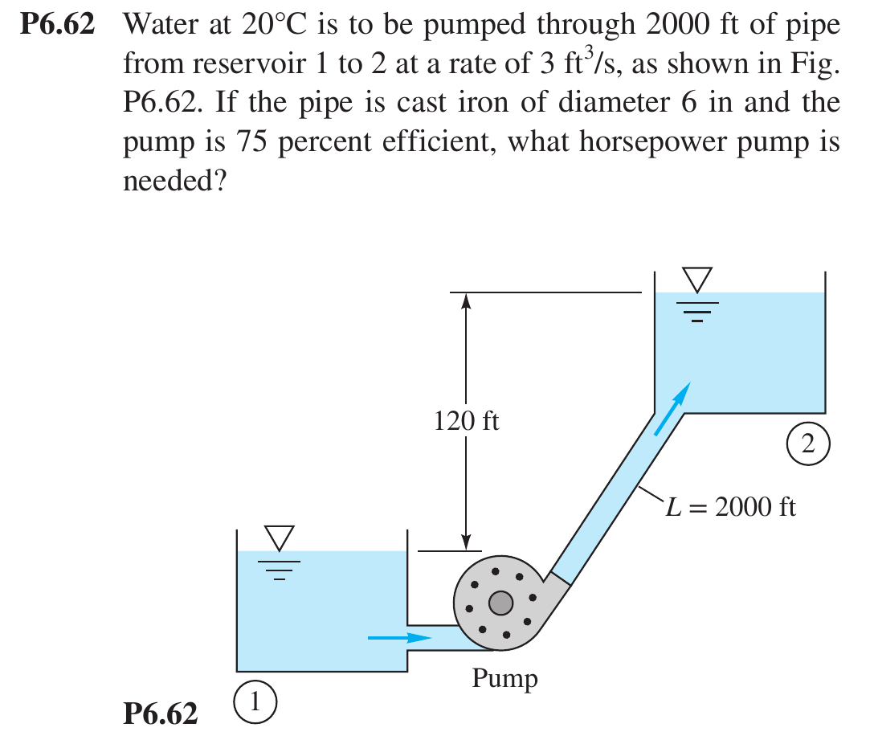

Step-by-step solutions

P3.117 · Ch 3 · Bernoulli
Concept: Bernoulli between two points with V = 0: tank pressure head converts to jet height.
Given
Water 20 °C (γ = 9790 N/m³). Air at 75 kPa gage above the water surface, which is 0.85 m above the outlet level. Free jet rises to height H (measured from the outlet level).
Assumptions
Steady, frictionless, incompressible, along a streamline from the water surface (1) to the top of the jet (2).
Solution
Step 1: pick the two points. At (1): p₁ = 75 kPa gage, V₁ ≈ 0 (large tank), z₁ = 0.85 m. At (2), the top of the jet: p₂ = 0 gage (open air), V₂ = 0 (the jet stops rising), z₂ = H.
Step 2: Bernoulli.
p₁/γ + V₁²/2g + z₁ = p₂/γ + V₂²/2g + z₂
75 000/9790 + 0 + 0.85 = 0 + 0 + H
H = 7.66 + 0.85 = 8.51 m
Takeaway
The jet top has V = 0, so all the pressure head plus elevation head reappears as height. With no friction, the pipe geometry between the points doesn't matter.
Answer: H ≈ 8.5 m

P3.121 · Ch 3 · Bernoulli + continuity
Concept: Venturi meter with a gas: ideal-gas density, manometer Δp, then Bernoulli.
Given
CO₂ at 20 °C, p₁ = 170 kPa (absolute), R = 189 J/(kg·K). D₁ = 10 cm, D₂ = 6 cm → β = 0.6. Meriam red oil SG = 0.827 → ρ_m = 0.827(998) = 825 kg/m³; h = 8 cm.
Assumptions
Steady, frictionless; the gas is treated as incompressible because Δp ≪ p (check at the end).
Solution
Step 1: gas density (ideal gas, Table A.4 R for CO₂):
ρ = p/(RT) = 170 000/(189 × 293) = 3.07 kg/m³
Step 2: manometer. Both legs contain CO₂, so subtract the gas density:
p₁ − p₂ = (ρ_m − ρ)gh = (825 − 3.07)(9.81)(0.08) = 645 Pa
(a) p₂ = 170 000 − 645 ≈ 169.4 kPa
Step 3: continuity + Bernoulli (horizontal, V₁ = β²V₂):
p₁ − p₂ = ½ρV₂²(1 − β⁴) ⟹ V₂ = √[2(645)/(3.07 × (1 − 0.6⁴))] = √[1290.6/2.670] = 22.0 m/s
(b) Q = V₂ π(0.06)²/4 = 22.0 × 0.002827 = 0.0622 m³/s ≈ 224 m³/h
Check: Δp/p = 645/170 000 = 0.4%, so treating the gas as incompressible is fine.
Takeaway
A gas Venturi works the same way as a liquid one. Get ρ from p/RT first. With a liquid manometer, ρgas is negligible next to ρm, but writing (ρ_m − ρ) shows you understand it.
Answer: p₂ ≈ 169.4 kPa; Q ≈ 224 m³/h

P3.126 · Ch 3 · Bernoulli / energy eq.
Concept: Pressurized tank draining; adding a head-loss term to Bernoulli.
Given
Kerosene 20 °C: ρ = 1.56 slug/ft³ (804 kg/m³). Tank air p = 20 lbf/in² abs; exit to p_a = 14.7 lbf/in² abs. Depth above the pipe centerline h = 5 ft. D = 1 in.
Solution
Step 1: points. (1) the free surface in the tank: p₁ = 20 psia, V₁ ≈ 0, z₁ = 5 ft. (2) the pipe exit: p₂ = 14.7 psia, V₂ = V, z₂ = 0.
p₁ − p₂ = (20 − 14.7)(144) = 763 lbf/ft²
(a) No losses:
(p₁ − p₂)/ρ + g h = V²/2 ⟹ V = √[2(763/1.56 + 32.2 × 5)] = √[2(489 + 161)] = 36.1 ft/s
Q = V π(1/12)²/4 = 36.1 × 0.005454 = 0.197 ft³/s (≈ 0.0056 m³/s)
(b) With losses h_f = 4.5V²/(2g): the energy equation gains one term on the right side:
(p₁ − p₂)/ρg + h = V²/2g + 4.5V²/2g = 5.5 V²/2g
V = 36.1/√5.5 = 15.4 ft/s, Q = 15.4 × 0.005454 = 0.084 ft³/s (≈ 0.0024 m³/s)
Takeaway
The loss term is written as K·V²/2g. Lump it with the exit kinetic energy, so (1 + K) multiplies V²/2g. Here the losses cut the flow by more than half. Watch BG units: ρ is in slug/ft³ and pressure in lbf/ft².
Answer: (a) 0.197 ft³/s (b) 0.084 ft³/s

P4.3 · Ch 4 · Kinematics
Concept: Convective acceleration from a velocity field; vector components and directions.
Given
u = x² − y² + x, v = −(2xy + y), steady 2-D, evaluate at (x, y) = (1, 2).
Solution
Step 1: velocity and gradients at (1, 2): u = 1 − 4 + 1 = −2, v = −(4 + 2) = −6.
∂u/∂x = 2x + 1 = 3, ∂u/∂y = −2y = −4, ∂v/∂x = −2y = −4, ∂v/∂y = −(2x + 1) = −3
(a) Convective acceleration (steady, so there is no ∂/∂t term):
a_x = u ∂u/∂x + v ∂u/∂y = (−2)(3) + (−6)(−4) = 18
a_y = u ∂v/∂x + v ∂v/∂y = (−2)(−4) + (−6)(−3) = 26
(b) Component of V in the direction θ = 40°: dot V with the unit vector n = (cos 40°, sin 40°):
V·n = (−2)(0.766) + (−6)(0.643) = −5.39
(c) Direction of maximum velocity is along V itself: θ = atan2(−6, −2) = 251.6° (|V| = 6.32).
(d) Direction of maximum acceleration: θ = atan2(26, 18) = 55.3° (|a| = 31.6).
Check: ∂u/∂x + ∂v/∂y = 3 − 3 = 0, so the flow is incompressible.
Takeaway
Write all four derivatives first, then plug in. The point and the sign bookkeeping are where exam points get lost. "Component in direction θ" means a dot product.
Answer: a = 18i + 26j; V₄₀ = −5.39

P4.17 · Ch 4 · Continuity
Concept: Integrate continuity to get v from u in a growing boundary layer.
Given
u = U(2η − 2η³ + η⁴), η = y/δ, δ = C x^½ (so dδ/dx = δ/(2x)). 2-D incompressible. Part (b): x = 1 m, U = 3 m/s, δ = 1.1 cm.
Solution
Step 1: ∂u/∂x by the chain rule. u depends on x only through η = y/δ(x): ∂η/∂x = −(y/δ²)(dδ/dx) = −η/(2x).
∂u/∂x = U f′(η)·∂η/∂x = −U η f′(η)/(2x), f′(η) = 2 − 6η² + 4η³
Step 2: continuity, ∂v/∂y = −∂u/∂x. Integrate from the wall with dy = δ dη, using v(0) = 0 (no slip):
v = (Uδ/2x) ∫₀^η η f′ dη = (Uδ/2x) ∫₀^η (2η − 6η³ + 4η⁴) dη
(a) v = (Uδ/2x)(η² − 1.5η⁴ + 0.8η⁵), η = y/δ
(b) Maximum v. dv/dη ∝ 2η − 6η³ + 4η⁴ = 2η(1 − η)²(1 + 2η) ≥ 0, so v increases all the way to η = 1, where the bracket equals 1 − 1.5 + 0.8 = 0.3.
v_max = 0.3 Uδ/(2x) = 0.15 Uδ/x = 0.15(3)(0.011)/1 = 0.0050 m/s
That is only 0.17% of U: v is very small in a boundary layer.
Takeaway
Given u, find v: (1) differentiate u with respect to x (chain rule when δ = δ(x)), (2) integrate continuity in y, (3) fix the constant with a boundary condition, usually v = 0 at the wall.
Answer: v_max ≈ 0.005 m/s

P4.57 · Ch 4 · ψ and φ
Concept: Stream function exists if continuity holds; potential exists only if irrotational.
Given
u = 2V(x/L − y/L), v = −2V y/L.
Solution
Step 1: continuity. If it holds, ψ exists. ∂u/∂x + ∂v/∂y = 2V/L − 2V/L = 0 ✓.
Step 2: stream function. Integrate u = ∂ψ/∂y:
ψ = ∫ 2V(x − y)/L dy = (V/L)(2xy − y²) + f(x)
v = −∂ψ/∂x = −2Vy/L − f′(x) ⟹ f′ = 0 ⟹ ψ = (V/L)(2xy − y²)
Step 3: vorticity. If it is zero, φ exists:
ω_z = ∂v/∂x − ∂u/∂y = 0 − (−2V/L) = 2V/L ≠ 0
The flow is rotational, so no velocity potential exists.
Takeaway
ψ needs continuity only (2-D incompressible). φ needs irrotationality. Always check before integrating. On an exam, show the check explicitly.
Answer: ψ = (V/L)(2xy − y²); no φ

P4.80 · Ch 4 · Exact Navier–Stokes
Concept: Gravity-driven film: reduce Navier–Stokes, no-slip wall + zero-shear free surface.
Given
Oil film of constant thickness δ on a vertical plate; x is normal to the plate, z is up, gravity acts in −z. w = w(x) only; air exerts no shear at x = δ.
Assumptions
Steady, incompressible, fully developed (∂/∂z = 0), u = v = 0. Pressure equals atmospheric everywhere, so ∂p/∂z = 0.
Solution
Step 1: continuity. ∂w/∂z = 0 ✓, consistent with w = w(x).
Step 2: z-momentum Navier–Stokes.
ρ(∂w/∂t + u∂w/∂x + v∂w/∂y + w∂w/∂z) = −∂p/∂z − ρg + μ(∂²w/∂x² + ∂²w/∂y² + ∂²w/∂z²)
The left side is 0 (steady, u = v = 0, ∂w/∂z = 0), ∂p/∂z = 0, and only ∂²w/∂x² survives:
μ d²w/dx² = ρg ⟹ w = (ρg/2μ)x² + C₁x + C₂
Step 3: boundary conditions. No slip: w(0) = 0 → C₂ = 0. Free surface (no shear): dw/dx(δ) = 0 → C₁ = −ρgδ/μ.
(a) w(x) = −(ρg/2μ)·x(2δ − x)
The profile is a half-parabola: zero at the wall, most negative (fastest downward) at the free surface, w_surface = −ρgδ²/(2μ), with zero slope there. Flow per unit width: q = −ρgδ³/(3μ).
(b) At the wall, dw/dx = −ρgδ/μ, so
μ = −ρgδ / (dw/dx)_wall
Takeaway
A free surface means τ = μ dw/dx = 0 there, which replaces the second no-slip condition. Gravity plays the role of the pressure gradient in driving the flow.
Answer: w = −(ρg/2μ)x(2δ − x)

P5.25 · Ch 5 · Pi theorem
Concept: 6 variables, 3 dimensions → 3 groups.
Solution
Step 1: list variables and dimensions. F = f(D, Ω, V, ρ, μ).
 | F | D | Ω | V | ρ | μ
Dims | MLT⁻² | L | T⁻¹ | LT⁻¹ | ML⁻³ | ML⁻¹T⁻¹

n = 6 variables, j = 3 dimensions → k = 3 groups. Repeating variables: ρ, V, D.
Π₁ = F ρᵃVᵇDᶜ: M: 1 + a = 0 → a = −1. T: −2 − b = 0 → b = −2. L: 1 − 3a + b + c = 0 → c = −2.
Π₁ = F/(ρV²D²) (thrust coefficient)
Π₂ = Ω ρᵃVᵇDᶜ: M: a = 0. T: −1 − b = 0 → b = −1. L: b + c = 0 → c = 1.
Π₂ = ΩD/V (inverse of the advance ratio)
Π₃ = μ ρᵃVᵇDᶜ: a = −1, b = −1, c = −1, giving μ/(ρVD). Invert it to the Reynolds number.
F/(ρV²D²) = fcn( ΩD/V , ρVD/μ )
Takeaway
Propeller practice uses ρ, Ω, D instead: C_T = F/(ρΩ²D⁴) and J = V/(ΩD). Any valid set is correct, because groups can be multiplied and inverted into one another.
Answer: F/(ρV²D²) = f(ΩD/V, ρVD/μ)

P5.31 · Ch 5 · Pi theorem
Concept: 5 variables → 2 groups; check against Hagen–Poiseuille.
Solution
Step 1: Δp/L = f(ρ, μ, D, Q). Dimensions: Δp/L is ML⁻²T⁻², ρ is ML⁻³, μ is ML⁻¹T⁻¹, D is L, Q is L³T⁻¹.
n = 5, j = 3 → k = 2. Repeating variables: ρ, D, Q.
Π₁ = (Δp/L) ρᵃDᵇQᶜ: M: 1 + a = 0 → a = −1. T: −2 − c = 0 → c = −2. L: −2 − 3a + b + 3c = 0 → −2 + 3 + b − 6 = 0 → b = 5.
Π₁ = (Δp/L) D⁵/(ρQ²)
Π₂ = μ ρᵃDᵇQᶜ: a = −1. T: −1 − c = 0 → c = −1. L: −1 + 3 + b − 3 = 0 → b = 1.
Π₂ = μD/(ρQ) (∝ 1/Re, since Re = 4ρQ/(πμD))
(Δp/L) D⁵/(ρQ²) = fcn( μD/(ρQ) )
Check with laminar theory: Hagen–Poiseuille gives Δp/L = 128μQ/(πD⁴). Multiplying by D⁵/(ρQ²) gives (128/π)·μD/(ρQ), so Π₁ = 41Π₂. The Pi groups contain the exact solution ✓.
Takeaway
Checking your groups against a known formula is a quick way to catch exponent mistakes.
Answer: (Δp/L)D⁵/(ρQ²) = f(μD/(ρQ))

P5.66 · Ch 5 · Similarity (cavitation no.)
Concept: Hold the cavitation number constant between two operating conditions.
Given
Seawater ρ = 1025 kg/m³, pv ≈ 2337 Pa, pa = 101 kPa. Cavitates at 21 m/s at 8 m depth. Re and Fr effects neglected.
Solution
Step 1: governing group. Cavitation depends on the cavitation number, which must be the same at incipient cavitation:
Ca = (p_∞ − p_v)/(½ρV²), p_∞ = p_a + ρgh
Ca = [101 000 + 1025(9.81)(8) − 2337] / [½(1025)(21²)] = 179 100/226 000 = 0.792
Step 2: at 20 m depth, solve for V with the same Ca:
V = √[2(p_a + ρgh − p_v)/(ρ·Ca)] = √[2(101 000 + 201 100 − 2337)/(1025 × 0.792)] = 27.2 m/s
Step 3: depth for 30 m/s:
ρgh = Ca·½ρV² + p_v − p_a = 0.792(0.5)(1025)(900) + 2337 − 101 000 = 266 900 Pa
h = 266 900/(1025 × 9.81) ≈ 26.5 m
Takeaway
When the problem says "Re and Fr negligible", the remaining group (here Ca) must stay constant. Deeper water means higher ambient pressure, which allows a higher speed before cavitation.
Answer: 27 m/s; ≈ 26.5 m

P5.71 · Ch 5 · Model scaling
Concept: Match the Euler number to scale a venturi meter to another fluid.
Given
Model: water (998 kg/m³), Vm = 4 m/s, Δpm = 5 kPa. Prototype: gasoline (680 kg/m³), Q = 9 m³/min = 0.15 m³/s, Δp_p = 15 kPa. Δp depends only on ρ, V and the diameter ratio.
Solution
Step 1: dimensional analysis. Δp = f(ρ, V, β) gives Δp/(ρV²) = fcn(β). Geometric similarity (same β) means equal Euler numbers.
Eu = Δp_m/(ρ_m V_m²) = 5000/(998 × 4²) = 0.313
Step 2: prototype velocity:
V_p = √[Δp_p/(ρ_p Eu)] = √[15 000/(680 × 0.313)] = 8.39 m/s
Step 3: diameter from the flow rate:
D_p = √(4Q/(πV_p)) = √(4 × 0.15/(π × 8.39)) = 0.151 m ≈ 15 cm
Takeaway
Scaling recipe: (1) find which groups matter, (2) hold them constant, (3) use the remaining given (here Q) to size the prototype. Viscosity is dropped here because the problem says Δp doesn't depend on it.
Answer: D ≈ 15 cm

P6.11 · Ch 6 · Energy eq. + manometer
Concept: Manometer on an inclined pipe reads piezometric head = head loss.
Given
Water 20 °C, V = 4 m/s, D = 6 cm, L = 5 m, z₂ − z₁ = 3 m (flow upward). Mercury manometer h = 135 mm, p₁ higher.
Solution
(a) Manometer. Walking through the manometer gives the difference in piezometric pressure:
(p₁ + γz₁) − (p₂ + γz₂) = (γ_Hg − γ_w) h
p₁ − p₂ = (13 550 − 998)(9.81)(0.135) + 9790(3) = 16 620 + 29 370 ≈ 46.0 kPa
(b) Energy equation 1 → 2. Same D, so V₁ = V₂:
h_f = (p₁ − p₂)/γ − (z₂ − z₁) = 46 000/9790 − 3 = 4.70 − 3 = 1.70 m
Equivalently: h_f = (ρ_Hg/ρ_w − 1) h = (12.58)(0.135) = 1.70 m
(c) Yes. The manometer measures the drop in p + γz, which for a constant-area pipe is exactly h_f, whatever the pipe slope. Elevation cancels inside the manometer.
(d) Friction factor:
f = h_f (D/L)(2g/V²) = 1.70(0.06/5)(19.62/16) = 0.025
Check: Re = VD/ν = 4(0.06)/1.002×10⁻⁶ = 2.4×10⁵, which is turbulent. f = 0.025 matches the Moody chart for a slightly rough pipe.
Takeaway
This is a favorite exam concept: on an inclined pipe the manometer reads head loss directly, while Δp includes the elevation change.
Answer: Δp ≈ 46 kPa; h_f ≈ 1.70 m; f ≈ 0.025

P6.14 · Ch 6 · Laminar flow
Concept: Energy eq. with laminar h_f; Re limit sets a maximum H.
Given
Water 20 °C (ρ = 998, μ = 0.001 kg/(m·s), ν = 1.002×10⁻⁶ m²/s). Tube L = 1 m, d = 2 mm; exit H below the tank surface (free jet). Neglect curvature and entrance losses.
Solution
Step 1: energy equation, from the tank surface to the exit (both at patm, Vsurface ≈ 0):
H = V²/2g + h_f, laminar: h_f = (64/Re)(L/d)(V²/2g) = 32μLV/(ρgd²)
Step 2: laminar limit. Re = 2300 gives V = 2300ν/d = 1.15 m/s:
H = (1.15)²/19.62 + 32(0.001)(1)(1.15)/(998 × 9.81 × 0.002²) = 0.068 + 0.941 ≈ 1.0 m
So the flow may stop being laminar if H exceeds about 1.0 m.
Step 3: H = 0.5 m. Solve the quadratic in V, where 32μL/(ρgd²) = 0.817 s:
V²/19.62 + 0.817 V − 0.5 = 0 ⟹ V = 0.590 m/s
Q = V π d²/4 = 0.590 × 3.14×10⁻⁶ = 1.85×10⁻⁶ m³/s ≈ 6.7 L/h
Check: Re = 0.59(0.002)/1.002×10⁻⁶ = 1180 < 2300, so the flow is laminar ✓. Using α = 2 for the laminar exit kinetic energy changes V by only a few percent.
Takeaway
In a laminar tube problem, h_f is linear in V, so the energy equation becomes a quadratic. Always confirm Re afterward.
Answer: H ≳ 1.0 m turbulent; Q ≈ 1.85×10⁻⁶ m³/s

P6.41 · Ch 6 · Turbulent, Type 2
Concept: Find the roughness that still delivers the required flow.
Given
Δz = 40 m, L = 350 m, D = 8 cm, water 20 °C, required weight flow 130 N/s. Neglect minor losses.
Solution
Step 1: required flow: Q = 130/9790 = 0.01328 m³/s, V = Q/A = 0.01328/0.005027 = 2.64 m/s, Re = VD/ν = 2.11×10⁵.
Step 2: energy equation, surface to surface: all 40 m goes to friction, h_f = 40 m. The maximum allowable f is
f = h_f (D/L)(2g/V²) = 40(0.08/350)(19.62/2.64²) = 0.0257
Step 3: allowable roughness. Solve Colebrook for ε/D with f = 0.0257 and Re = 2.11×10⁵:
ε/D = 3.7[10^(−1/(2√f)) − 2.51/(Re√f)] = 0.0025 ⟹ ε_max ≈ 0.20 mm
Material | ε (mm) | Actual f | Q delivered (m³/s) | Weight flow (N/s) | OK?
(a) Galvanized iron | 0.15 | 0.0239 | 0.0138 | 135 | Yes
(b) Commercial steel | 0.046 | 0.0189 | 0.0155 | 152 | Yes
(c) Cast iron | 0.26 | 0.0274 | 0.0129 | 126 | No

The "Q delivered" column comes from solving the Type 2 problem for each material (iterate V = √(2gh_fD/(fL)) with Colebrook).
Takeaway
Turn "can material X work?" into "what is the maximum allowable f, or ε?". That gives one calculation instead of three iterations.
Answer: galvanized & steel OK; cast iron no

P6.44 · Ch 6 · Turbulent, Type 1
Concept: Smooth-pipe friction factor at high Re.
Given
Mercury 20 °C: ρ = 13 550 kg/m³, μ = 1.56×10⁻³ kg/(m·s). D = 7 mm, L = 4 m, V = 5 m/s, glass tubing (smooth, ε ≈ 0).
Solution
Re = ρVD/μ = 13 550(5)(0.007)/0.00156 = 3.04×10⁵ (turbulent)
Smooth-pipe Colebrook (ε = 0), iterated: 1/√f = −2 log₁₀(2.51/(Re√f))
f = 0.0144
h_f = f (L/D)(V²/2g) = 0.0144(4/0.007)(25/19.62) = 10.5 m
Δp = ρg h_f = 13 550(9.81)(10.5) = 1.40×10⁶ Pa ≈ 1400 kPa
Takeaway
Head loss is in meters of the flowing fluid. Mercury is 13.6 times denser than water, so the same hf costs 13.6 times more pressure. Always use the flowing fluid's ρ in Δp = ρghf.
Answer: h_f ≈ 10.5 m; Δp ≈ 1.4 MPa

P6.62 · Ch 6 · Pump + pipe system
Concept: Pump head = lift + friction; power = ρgQh/η.
Given
Water 20 °C (BG): ρ = 1.94 slug/ft³, μ = 2.09×10⁻⁵ slug/(ft·s), γ = 62.4 lbf/ft³. Q = 3 ft³/s, L = 2000 ft, D = 6 in = 0.5 ft, cast iron ε = 0.00085 ft, Δz = 120 ft, η = 0.75. Minor losses neglected.
Solution
Step 1: flow parameters:
V = Q/A = 3/(π(0.5)²/4) = 15.3 ft/s, Re = ρVD/μ = 1.94(15.3)(0.5)/2.09×10⁻⁵ = 7.09×10⁵
ε/D = 0.00085/0.5 = 0.0017 ⟹ Colebrook: f = 0.0227
Step 2: head loss:
h_f = f (L/D)(V²/2g) = 0.0227(4000)(15.3²/64.4) = 330 ft
Step 3: energy equation, surface 1 → surface 2 (p = p_atm and V ≈ 0 at both):
z₁ + h_pump = z₂ + h_f ⟹ h_pump = 120 + 330 = 450 ft
Step 4: power:
P = γQh_pump/η = 62.4(3)(450)/0.75 = 112 000 ft·lbf/s ÷ 550 = 204 hp
Takeaway
Pump head = static lift + all losses. Divide by efficiency to get shaft power. Remember 1 hp = 550 ft·lbf/s. Friction (330 ft) dominates the 120-ft lift here, which is why pipe diameter matters so much.
Answer: ≈ 204 hp

